## **Introduction**

* Cloud computing is the delivery of computing services over the internet. Computing services include common IT infrastructure such as virtual machines, storage, databases, and networking.

## **Shared Responsibility Model**

* The Shared Responsibility Model is a security and compliance framework that outlines the responsibilities of cloud service providers (CSPs) and customers for securing every aspect of the cloud environment, including hardware, infrastructure, endpoints, data, configurations, settings, operating system (OS), network controls and access rights.
* With the shared responsibility model, these responsibilities get shared between the cloud provider and the consumer. Physical security, power, cooling, and network connectivity are the responsibilities of the cloud provider. The consumer isn’t collocated with the datacenter, so it wouldn’t make sense for the consumer to have any of those responsibilities.

### **Types of Cloud Services**

#### Infrastructure as a service (IaaS):

* IaaS places the most responsibility on the consumer, with the cloud provider being responsible for the basics of physical security, power, and connectivity. On the other end of the spectrum.

#### Software as a service (SaaS):

* SaaS provides a complete software solution that you purchase on a pay-as-you-go basis from a cloud service provider. It places most of the responsibility with the cloud provider.

#### Platform as a service (PaaS):

* Is middle ground between IaaS and SaaS, PaaS includes infrastructure servers, storage, and networking—but also middleware, development tools, business intelligence (BI) services, database management systems, and more. PaaS is designed to Developers to build applications.

In an on-premises datacenter, you own the whole stack. As you move to the cloud some responsibilities transfer to Microsoft. The following diagram illustrates the areas of responsibility between you and Microsoft, according to the type of deployment of your stack.

When using a cloud provider, you’ll always be responsible for:

* The information and data stored in the cloud
* Devices that are allowed to connect to your cloud (cell phones, computers, and so on)
* The accounts and identities of the people, services, and devices within your organization

The cloud provider is always responsible for:

* The physical datacenter
* The physical network
* The physical hosts

Your service model will determine responsibility for things like:

* Operating systems
* Network controls
* Applications
* Identity and infrastructure

## **A diagram of cloud computing AI-generated content may be incorrect.Cloud Types**

### Public :

A cloud environment provided by a third party (like Microsoft Azure, AWS, or Google Cloud) that organizations and individuals can use via the internet.

**Advantages**:

* + Low cost due to the pay-as-you-go model.
  + Offers high scalability.
  + There is no need to maintain infrastructure as it is managed by service providers.

### Private :

A cloud environment that is dedicated and designed for use by a single organization.

Advantages:

* + High level of security and privacy since the infrastructure is exclusive to the organization.
  + Full control over resources and their management.
  + Suitable for companies that need to comply with strict regulations (e.g., healthcare or financial sectors).

### Hybrid :

A combination of private and public clouds that work together to meet an organization’s needs.

Advantages:

* + Provides **great flexibility**
  + **Lower cost**
  + Offers **scalability** while maintaining **data security**.

## **Configuring an Azure Subscription**

* Azure subscription is a base container that comprises of a group of related business or technical resources. The group of resources are used and billed together.

#### **Step 1: Sign in to the Azure portal**

* Sign in to the [Azure portal](https://portal.azure.com/) by entering your credentials and clicking the “Sign in” button.

#### **Step 2: Navigate to the subscriptions**

Scroll down and click the “Subscriptions” tab.

#### **Step 3: Add a subscription**

Click the “Add” button to add a new subscription.

#### **Step 4: Select your subscription**

Select the subscription according to your requirements. It will navigate to the billing profile if it is not set up already.

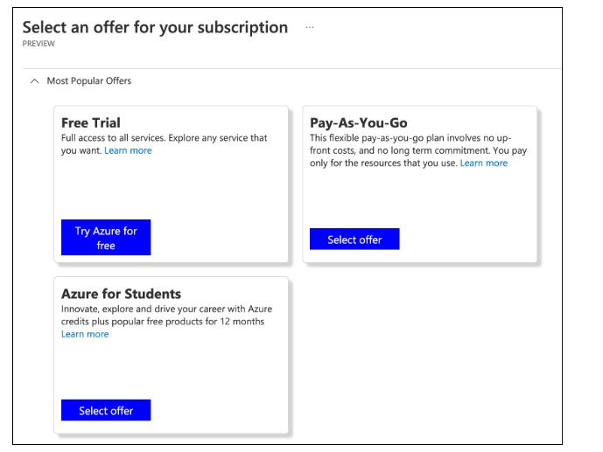

#### **Step 5: Billing account**

Set up your billing profile by adding your credit card information.

#### **Step 6: Create a subscription**

Once the billing account is completed, go to the “Subscription” page and click the “Add” button.

Click the “Basic” tab and do the following:

* Write the subscription name.
* Select the billing account for the payment of the new subscription.
* Select the billing profile for the payment of the new subscription.
* Select the invoice section for the payment of the new subscription.
* Select your plan.
  + If you are using the subscription for development or testing purposes, select Microsoft Azure Plan for DevTest.
  + Select Microsoft Azure Plan otherwise.

Click the “Advanced” tab and do the following:

* Select the subscription directory. Your subscription will be attached to the selected Azure Active Directory (Azure AD).
* Select the management group. Your subscription will be attached to the selected Azure AD management group.
* Select the subscription owner. You can add multiple owners from the selected subscription directory only.

**Tags**

Enter the tag pairs for the Name and Value in the “Tags” tab.

**Review + create**

Go to the “Review + create” tab and confirm the subscription details. You’ll see a Validation passed message.

Once you review the subscription details, click the “Create” button to create the subscription

We have created a Microsoft Azure subscription.

### Creating a Resource Group in Azure

**Method 1: Using Azure Portal**

1. Log in to the **Azure Portal**.
2. Search for **Resource Groups** in the search bar.

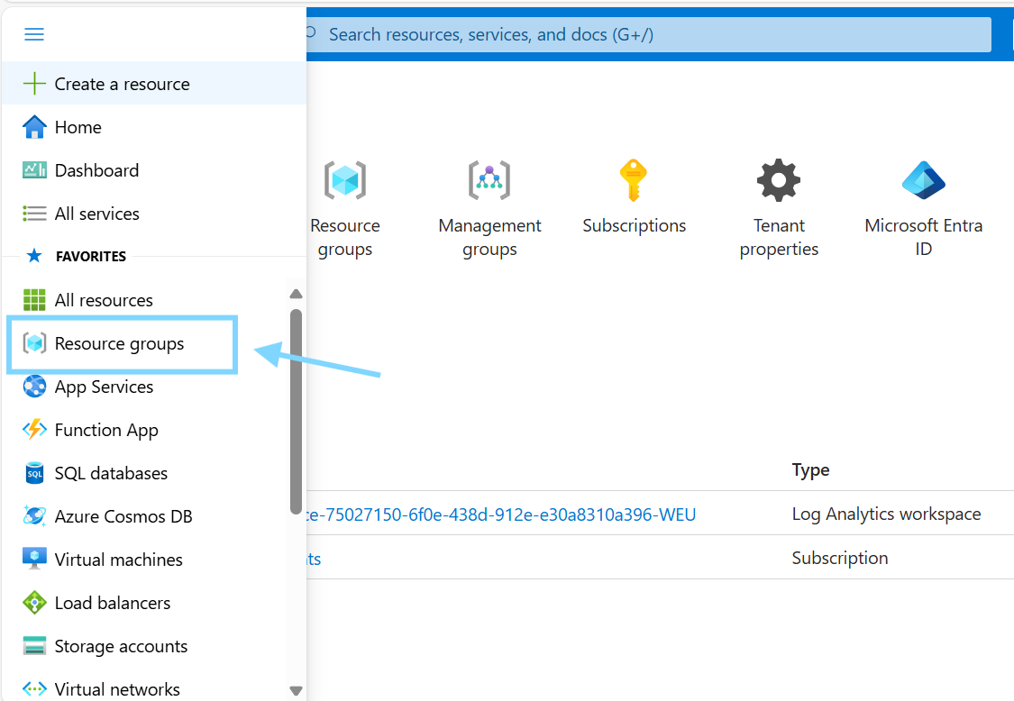

1. Click **Create**.

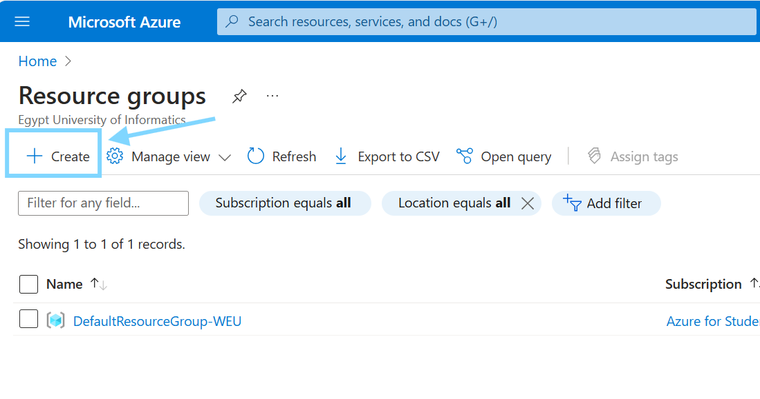

1. Select your **Subscription** and Enter a **Resource Group Name** (e.g., it-department).

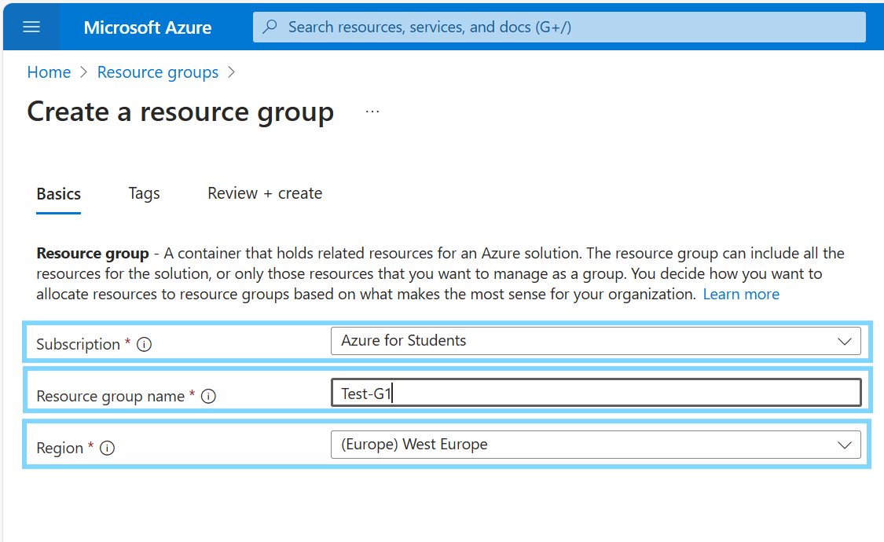

1. Choose a **Region** (e.g., East US, West Europe).
2. Click **Review + Create**, then **Create**.

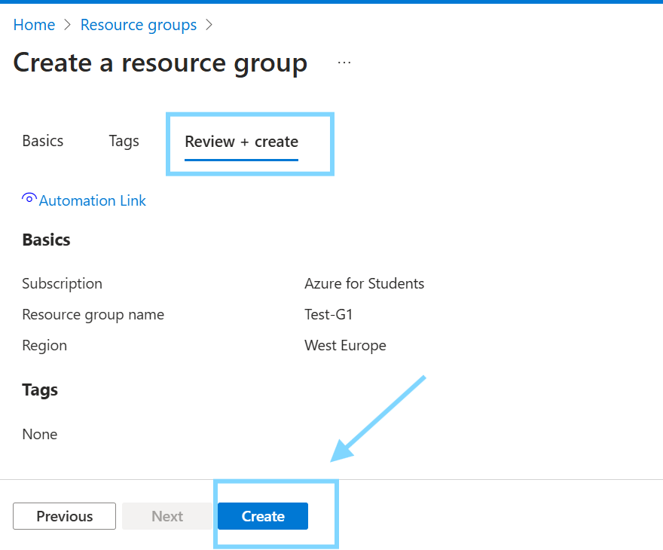

**Method 2: Using Azure CLI**

Run the following command in Azure CLI:

**Method 3: Using Azure PowerShell**

Run the following command in PowerShell:

